PRESS RELEASE
CONTACT: Mary Beth Duehr
Duehr & Associates, LLC
1902 Wright Pl, Ste 200
Carlsbad, CA 92008
(760) 918-5622
marybeth@duehrandssociates.com

Sonoma Forge’s Custom Showers Bring Tremendous Design Flexibility

Hand-forged in the USA, Sonoma Forge’s industrial-style showers offer distinctive styling along with the versatility to overcome any size, space, or aesthetic challenge

(Petaluma, CA, November 22, 2022) Sonoma Forge, whose hand-forged bath fixtures elevate humble plumbing elements to designer status, continues to push boundaries with custom showers that meet the diverse needs of designers and their discerning clientele. The manufacturer’s WaterBridge showers can be modified for height, width, mounting style, and functionality to accommodate project challenges or to simply elevate a bath space in unique ways.
“It all starts with our standard product, and when it doesn't fit the application that's in an existing situation, we help customize the product to make it work,” said Erik Ambjor, President of Sonoma Forge. “A lot of our products started out as a custom product and then the custom version was so popular that we turned it into a standard product in our lineup.”

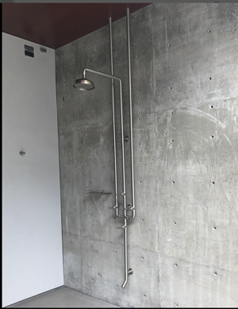
For example, for this swimming pool shower, there was no water supply on the wall or floor, so Sonoma Forge customized its standard shower system into a ceiling mount connected to the water supply available above.

“Many manufacturers are mostly concerned with volume, which prevents much customization to their lines,” Ambjor said. “Because our products are made by real artisans, we’re nimbler and more flexible, and able to make changes that preserve the designer’s vision by meeting individual project needs.”
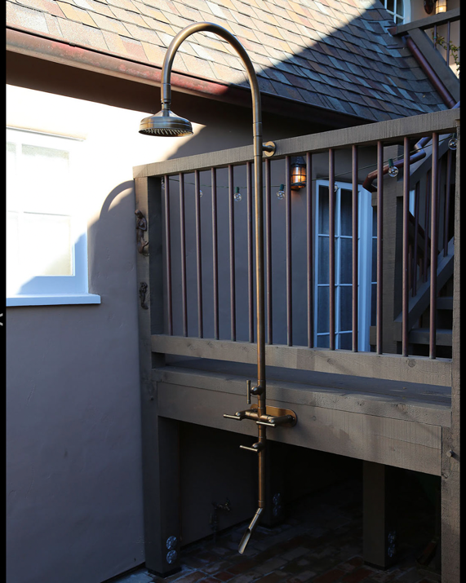
For this outdoor project, the designer requested a gooseneck shower arm to add a touch of elegance to the standard, angular industrial-style fixture. Since that project, the gooseneck arm has become a popular special-order item with our customers.

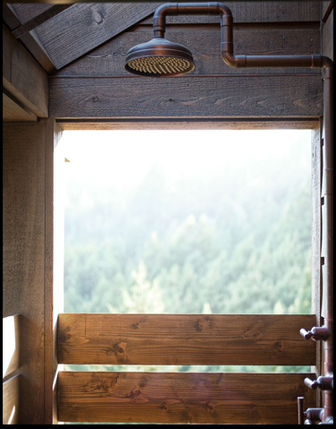
The ability to customize Sonoma Forge’s showers not only enhances design aesthetics, but can solve tough challenges, as was the case for this project featuring a shower arm with three 90-degree bends. The need arose after the installer misjudged the rough-in height, resulting in the showerhead being too low for the homeowner. The new shower arm raised the rainhead up to the appropriate height without the contractor having to reopen the wall and move the supply lines.

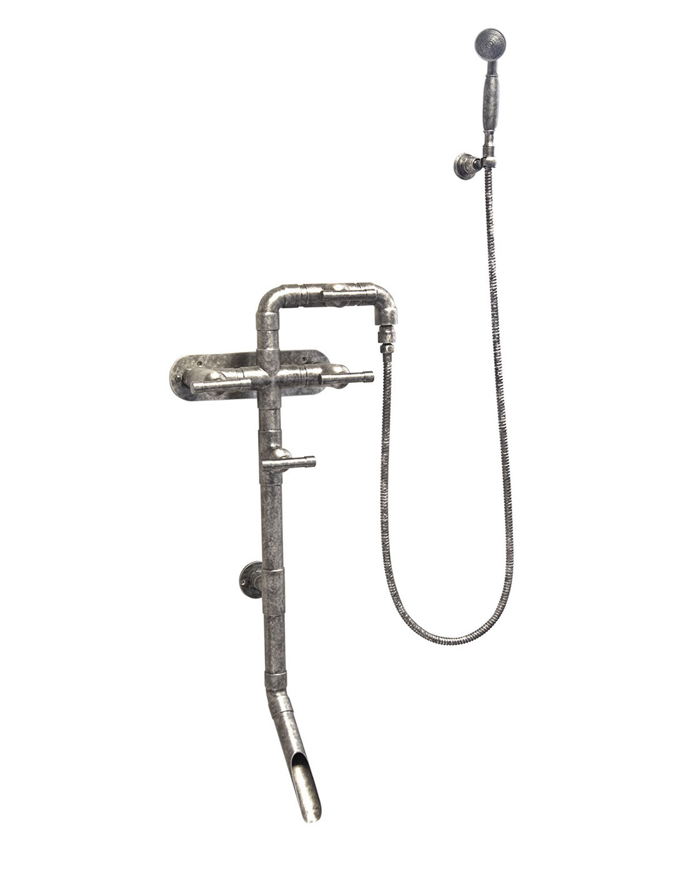
In some scenarios, the showerhead is eliminated altogether, as was the case for this custom unit, where the client only wanted a handshower and foot wash.

“These are just a few examples of custom products we have produced in response to a designer’s particular circumstances. Custom lengths, heights, and widths are easy for us to achieve,” Ambjor said. “We enjoy responding to these types of challenges to enable our products to work in a variety of new situations.”

Similar customizations are also available for Sonoma Forge’s lavatory faucets.

About Sonoma Forge
Located in the heart of Northern California’s wine country, Sonoma Forge’s roots are steeped in a rich history of industrial foundries where craftsmen hand forge metals. We celebrate the art of skillful metalworking and machining by highlighting the beauty of metal in our unique line of designer faucets and tub fillers, dramatic shower systems, and coordinated bath accessories. Our distinctive product line offers homeowners refreshing design options with a decidedly masculine sense of style that enhances any setting, whether urban loft, country villa, or boutique hotel. Sonoma Forge’s artistry and attention to detail is supplemented with innovative technology in models offered with Sans Hands, our exclusive sensor faucet technology. All Sonoma Forge products are handcrafted and assembled by artisans dedicated to forging the finest, most extraordinary products on the market. For more information about Sonoma Forge, call 1-800-330-5553 or visit SonomaForge.com.
###

